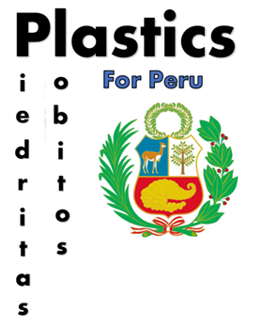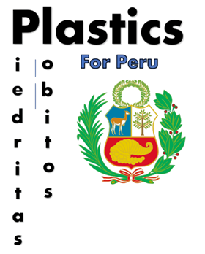

**Sustainable Plastic Recycling**

**UK2021-048**

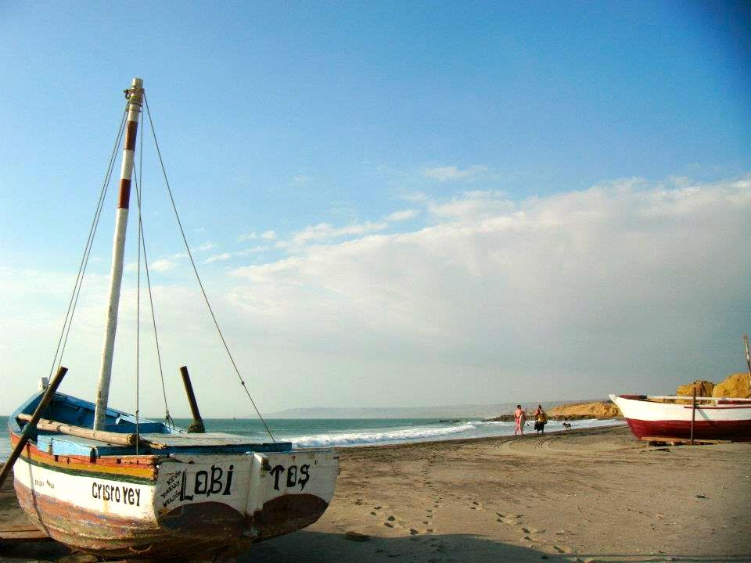

Callum Jardine Andrew Leahy

Cameron Maxwell Ross Brown

Chi Hang Tse Zeon Ojuoko

Course director: Reza Mohammadi Word count: 3984

**EWB Project – Plastics for Peru**

**Engineers without borders 2020**

# Contents

Contents 1

Executive Summary 3

1 Introduction 5

1.1 Peru 5

1.2 Original Designs 5

2 The Design 7

2.1 How does the idea work? 7

2.2 Sourcing Plastics 7

2.3 Preparing Plastics for Melting 8

2.4 Melting plastics 8

2.5 Moulds 9

2.6 Maintenance and repairs 9

2.7 Quality Assurance 10

2.8 Energy 10

3 Economics 12

4 Short-Term Plan 14

4.1 Goals of the project 14

4.2 The set-up of the project 14

4.3 Cradle to grave diagram 15

4.4 SWOT analysis 16

4.5 PESTEL analysis 17

5 Solutions 18

5.1 Table of Solutions 18

5.2 How solutions will tackle problem areas 18

6 Risks and Safety 19

6.1 Health and safety issues 19

7 Sustainability and Ethics 22

7.1 Environmental 22

7.2 Economic 22

7.3 Social 22

7.4 Ethics 22

8 Long-Term Plan 23

8.1 Future Management 23

8.2 Expanding the Project Reach 23

8.3 Machine Improvements 23

9 Improvements 24

9.1 Cost Efficiency Surrounding the Production of Bigger Items 24

9.2 Outreach for a More Reliable Plastic Supply 24

9.3 Reducing Emissions 25

10 Reflective Summary 26

11 References & Bibliography 27

12 Appendicies 32

12.1 Typing of Plastics & if they are recyclable 32

12.2 Case Studies 33

12.3 Fault report checklist 34

12.4 Gannt Charts 35

12.4.1 Team Gantt Chart 35

12.4.2 Long Term Gantt Chart 36

12.5 Economics 37

12.5.1 Cash Flow Statement and IRR 37

37

12.5.2 NPV 38

12.5.3 Closing Monthly Balance 39

12.5.4 Feasibility Table 39

12.6 The Team 40

12.7 Personal Statements 41

# Executive Summary

Plastics for Peru is an initiative with the goal of putting an end to the plastic waste problems that Lobitos and Piedritas are currently facing. However, within these communities there is much more to be done that removing the plastic waste, the issues caused by these other challenge areas only heightened by the rise of the COVID-19 pandemic. This project aims to turn this plastic waste into items that can act as a solution to these other challenge areas. Providing a single scheme that can aid a number of sectors, maximising the effectiveness of the attempt to help these communities.

As an overview, this project will operate by setting up plastic collection points across the town of Lobitos, along with this, a low-cost plastic processing plant will also be constructed from scrap materials. This project takes inspiration from the open-source community project known as ‘Precious Plastics’ where design specifications for creating plastic processing machines out of low-cost materials have been developed, presenting a remarkable effectiveness to the plastic recycling market. This technology includes three machines: a plastic waste shredder, an injection moulder, and an extrusion moulder. With the help of specially designed moulds, these machines work together to process waste plastic into a chosen object, these objects having the potential to greatly help a developing community. We strive to utilise this technology and implement it within Lobitos and Piedritas, creating items that will actively benefit each location. Such items include face shields to prevent the spread of COVID-19, classroom supplies that will enhance the educational capabilities of the region, water collection tanks to help offset the water sanitation problems, widely available recycling bins to completely irradicate the plastic waste crisis, and many more.

All it requires to produce a new item is a specially designed plastic processing mould, these moulds having the ability to fit almost any specification. This versatility allows the project to be developed to face a number of current scenarios, along with any unforeseen scenarios that could crop up in the future. In addition to this, these same machines can also be utilised to produce items that the community have previously enquired about, such as modular housing, where the limitations that exist within a poorer region to produce such an item can be easily reduced.

This project costs around £65,000 to set up, this is enough expenditure to fully cover the first two stages of the project. Included in the cost for these first two stages is the creation of our own means of energy production, all so we do not require support from the often-unreliable national grid. It is the benefit of this project to present a reliability and adaptability that cannot be matched, allowing for a bright future, one where the hinderances upon Lobitos and Piedritas can be lifted.

A key benefit of the project is the plan to get local into work as a part of the team, with the long-term goal of, eventually, completely handing off the project to the community itself. This is to be done through an extensive training scheme that will allow these individuals to operate and maintain the machines, an act that will help to generate a sustainable job scheme within the community.

In terms of sourcing this money, the funding for this project will come in the form of grants, where brands like ‘Coca Cola’ have a vast history of helping initiatives such as ours within these regions. Down the line, it is planned that souvenir style items will be produced and then sold around the tourist hotspots, this helps move the project towards a new level of self-sufficiency, on that down the line might even make the project more appealing to other grant schemes.

The potential of this project is parallel to the success of the initiative that inspired us, `precious plastics`. This collective is actively working to make sure the machines that they develop from scrap materials are the most effective at the lowest possible cost. A hope to fully partner with this scheme and work together to deliver and implement these machines in locations around the world is a part of the long-term success plan. This expansion will help to solve the key issue with a small plastic recycling plant, this being the value for money in producing bigger items. With a larger base of plastic processing workshops, this cost efficiency will decrease and allow the versatility and ability of the project to cater to any requirement of the region its based in to be as great as possible.

# Introduction

## Peru

The communities of Lobitos and Piedritas are located on the northern coast of Peru, they have respective populations of around 1300 and 400. Despite profitable tourism industries in both communities, most notably the surfing attraction of Lobitos, both communities still have high levels of poverty as much of the money made from these tourists does not go to locals or the community. In order to help improve the quality of life of the people of these communities it is the intention of the project to not only directly address their growing waste issue but also recycle the plastic portion of this waste to benefit the community. Plastic pollution has become an issue of growing public concern in recent years; therefore, it is important on a global scale that actions such as these are taken. Previous attempts to implement recycling in the region haven’t been successful but hopefully as plastic will be being recycled into products which the community can actively see benefitting them, this will help to create a community ethos more positive towards recycling. This is essential to the longevity of the project and so we will be consulting the community at every stage of the project and employing locals at a fair wage. This will allow us to create products which are in tune with what the community actually need. This will also allow new solutions to be implemented to perhaps currently unforeseen issues, such as covid-19 transmission would have been a couple of years ago. In addition to creating plastic items which can help the community, certain products will also be created to sell to tourists, allowing us to reinvest more money into helping the community and is a good way for the community to profit more from the tourism.

## Original Designs

Unfortunately, Lobitos and Piedritas face a number of problems, finding solutions to which is vital to creating a well ran and maintained community. Throughout the decision-making process it was deemed that waste was the most vital category to focus our attention to as a number of other issues such as food, sanitation and build environment are closely intertwined within the bigger issues created by the waste problem.

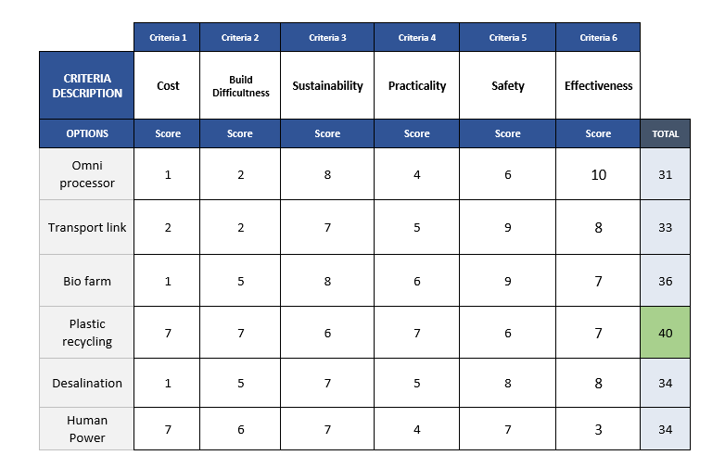

Table 1 - shows the initial project ideas ranked on a scale from one to ten, the lower the number the worse the design performed in that specific category.

The designs were ranked across 6 criteria, the option possessing the highest total was selected as the topic for this project. As outlined in Table 1, plastic recycling proved to be the most viable option.

# The Design

## How does the idea work?

Put simply, recycling plastic is not the sole aim of this project. The key behind this design is not only providing a solution to the overflow of plastic waste in both Lobitos and Piedritas, but to re-use this plastic in a feasible and effective manner. Plastic can be broken down and processed in order to produce useful items such as classroom supplies – rulers, and protractors etc, all capable of helping the community of Lobitos and Piedritas. With the COVID-19 global pandemic looming, producible items include protection equipment, including face shields and face mask clips. Essential for allowing tourism, one of the main economic sectors, to return to this region.

Waste plastic is retrieved from around the community using set collection points, these are constantly monitored, and the plastic brought to the machine shop by a retrieval team. They are then put through the machines within the facility. The machines shown below, in figures 1.1, 1.2, and 1.3, are the only devices used across the project. These are pre-built within the UK by experts and transported to the station in Lobitos.

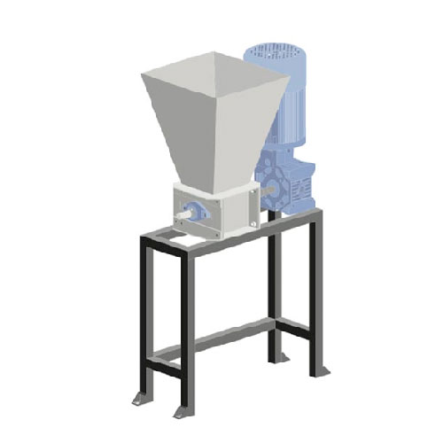

**The Shredder**

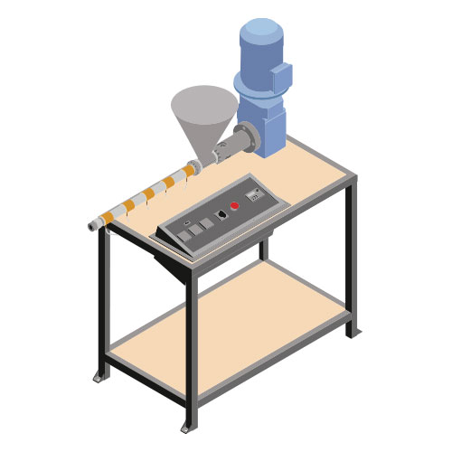

**The Extrusion Moulder**

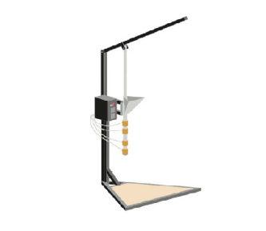

**The Injection Moulder**

*Figure 2.1, 2.2, & 2.3 – Open-source equipment diagrams from Precious Plastics. The same as the machines built in this project.*

## Sourcing Plastics

Plastic waste will be collected from around the local area. At the beginning of the project plastic will only be collected from Lobitos, most waste plastic in this location resides beside the coast and near the dump site. Undeniably, the plastic waste being collected from this community will eventually run out, and therefore a problem will arise. Furthermore, it is the hope of the project to have an expansion of the production line, detailed in section 5, leading to a situation where the consumption of plastic will increase with the supply decreasing. As a solution, plastic recycling bins will be placed around Lobitos for residents to put their unwanted plastic waste in, this is to be collected after a specific amount of time. If the plastic waste collected from only Lobitos is still not enough, there is a scope to expand to more regions in Peru, including Piedritas, allowing funds to finance the collection of all this raw material. The possibility of obtaining plastic waste from other countries is also feasible, however this would only occur very long term.

## Preparing Plastics for Melting

There are many variations of plastic, such as polypropylene, polystyrene, polyvinylchloride etc. In order to produce items out of plastic they have to undergo a melting stage, in preparation for this they need to be separated into their respective plastic types. This is largely due to the difference in properties, namely the melting temperature. Separating these plastics into their own variation can be difficult as they may have the same colour, texture, and appearance. The best ways to identify the typing of a plastic are:

* Looking for the recycle logo on the plastic, it will identify which type of plastic was used to make the product. Often numbered 1-7.
* Memorising – most of the time, same products are made from the same type of material, e.g. Legos are made from ABS and bottle caps are made from HDPE.
* Visual and physical properties – as previously mentioned, different plastics have different properties. Plastics such as polystyrene have a breakable sound when ‘squashed’ whereas polyethylene possesses a more flexible and less brittle structural properties.

Plastics that are safe to melt include:

PET, HDPE, PVC, and PP.

The 3 steps to processing waste plastic are:

1. Shredding
2. Melting
3. Moulding

After identifying plastics, they are to be broken down into smaller parts, this is done via a shredder. This readies all the collected plastic for the next stage of the process.

## Melting plastics

Shredded plastic requires a lower amount of energy to melt and will also give a more consistent phase transition to a liquid, not creating a heavily viscous, chunky plastic slurry. It is important to note that in the process of melting plastic VOCs (Volatile Organic Compounds) are formed. Though the amount produced through a production of this scale is relatively small, they can still cause damage to the human body, therefore health and safety hazards should be considered a very high priority. It is important to note that, for costing purposes, the workshop is outside. The safety implications of this decision are outlined in section 6, though the impact here is that the warm outside temperature will mean the machines may be prone to overheating.

## Moulds

Once melted, the plastic is injected into an item specific mould where it is left to set, forming the specified products which is then ready to be distributed. The distributed items are produced in different stages, items that are smaller and deemed more effective are produced in the early stages. Effective products follow the description that they are easy to produce, good at raising project awareness amongst the locals, and require a small amount of plastic waste to produce. For each unique item that is produced, a new mould must be ordered. Mould manufacturers exist across the world in great numbers, at low cost, and a great level of specificity.

The solutions created in the first stages are focussed around tackling the COVID-19 pandemic.

## Maintenance and repairs

Maintenance inspections will be carried out weekly following the fault report checklist [appendix 1.13]. If a fault is detected, then an employee should determine if it is a small or larger fault and take appropriate action based on the maintenance guidelines.

**Guidelines**

Small faults:

1. Shredder wear can be easily resolved by unscrewing the blade and using a knife sharpener to sharpen the blade which can be purchased for around £15.
2. Holes in manufactured items can be patched by melting additional plastic and sealing the hole.

Larger faults:

1. Fixing larger faults is outside of the training that can be provided to employees; hence, all faults of this scale are outsourced to an expert. This is best for both the employee safety and the efficiency of repair.
2. It is recommended that faulty parts are replaced by brand new ones. The costing can be seen in the section 3; however, it is not expected that new parts are to be needed until well after the time employees are fully trained on maintenance and repairs.

## Quality Assurance

Throughout the production process employees will be encouraged to maintain high standards of quality. In order to ensure nothing is missed, after the items have been produced each one will go through a quality inspection to ensure that all produced items are kept to the same high standard. This will be achieved by having an employee check the items for set benchmarks of quality.

## Energy

For the moulds to be successfully manufactured, a power source is required to shred and melt the plastics without harming the environment. Therefore, sustainable methods for generating energy were evaluated. It was discovered that the most suitable renewable source was solar energy. This method of energy production allows sunlight to be converted into electrical energy through the photovoltaic cells in solar panels that can connect to the main power grid to be distributed amongst machines.

A 25kW Hybrid Solar System is used to generate an average of 3000 units per month and has 150 square meter area for installation. Since the project has an overall maximum power consumption of 20kW, an energy source that exceeded the power requirements was incorporated. This allows residual energy to be delivered to the grid to assist in energy stability in Lobitos and Piedritas. Prominent figures in the area, such as Teófilo Erazo can be consulted as he is already working to electrify Piedritas and has so far electrified 80% of the town.

Peru is known for their consistent high-intensity sun that provides a valuable source of energy. As renewable energy methods were researched, the conclusion that was reached showed solar energy was the most optimal. This is further supported by figure 2.7.1.

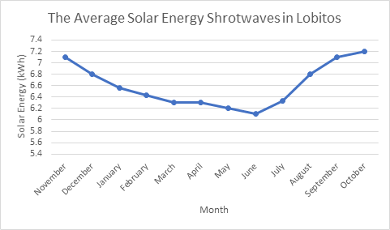

Figure 2.7.1 - The average daily shortwave solar energy reaching the ground per square meter

The results show that sunlight is consistent through the seasons in Lobitos. Evident from the solar energy averages that range from 6.1kWh to 7.2kWh. The solar energy can effectively be transmitted through the hybrid solar system into an electric energy output that powers the machines. The decision for the hybrid solar system is due to the inclusion of a hybrid inverter. This converts the direct current from the solar panels to alternating for the machines, while additionally charging the battery back-up system. Additionally, the backup capability reduces the demand for power because energy can still be distributed, even when no light is present for the solar panels to produce the energy.

# Economics

To fund this project, an estimated cost of £65,235.05 is required as stated in the table below:

*Figure 3.1.1 – Estimation of initial expenditure*

And the same chart with broken down figures can be seen here:

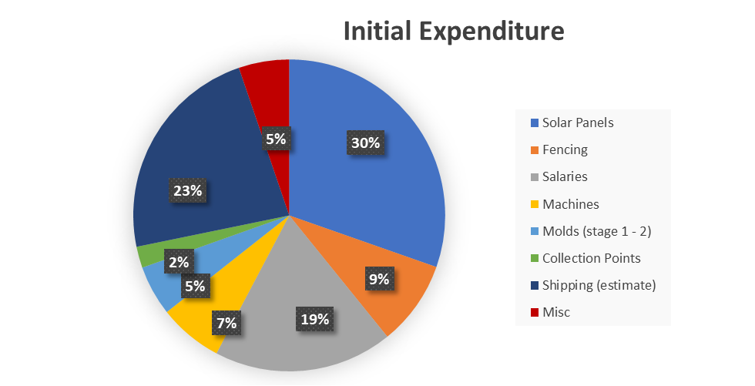

*Figure 3.1.2 – Estimation of initial expenditure*

In order for the project to be financially feasible, the net present value (NPV) must be calculated. If this value is greater than 1, a business is deemed profitable and is investable. The NPV for Plastics for Peru is projected to be £84,914.63 for the first 24 months of trading. The Internal Rate of Return (IRR) also needs to be considered. It is essential to look at this to determine if an organisation can be successful and if the value is greater than one, the organisation is profitable. The IRR of Plastics for Peru over 24 months is estimated to be 7%. However, it must be clarified that this is a charity, meaning any net profits will be reinvested into the local community as no one apart from the community should be reaping the rewards.

To ensure the project can continue, it is essential to know how many items of a particular type must be produced in order to make the project feasible. The benefits stemming from the production of an item must outweigh the cost of the required mould, as shown in appendix 11.5.4. This means that the produced items must remain effective, limiting the money wasted. As an example, spending multiple thousands making a massively large recycling bin would simply be impractical if it could be bought for £250.

In order to obtain the initial investment, various avenues could be pursued. These vary from applying for grants from The Global Environment Facility’ (GEF), UK Direct Aid and the Small Charities Challenge Fund (SCCF) who all give grants to charities that are working to help the lives of those in poverty and to tackle climate change, with UK Direct Aid offering up to £100,000 with the others varying. Other options to consider is partnering with companies like Coca – Cola who set aside millions of dollars a year to give as funding to charities and organisations. Lastly, an event such as a fun run could be organised. This would help generate the needed income and also help to promote the organisation.

# Short-Term Plan

## Goals of the project

The purpose of this project is to provide a sustainable way to improve the communities of Lobitos & Piedritas through a scheme that can be permanently implemented into their societal structure. In the early stages of the project, Plastics for Peru aim to set up a production station on the outskirts of Lobitos, along with 4 collection points. The locations of which shown in figure 4.1.1.

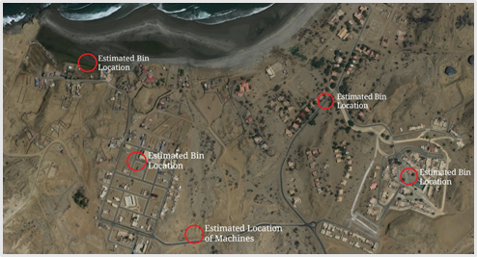

*4.1.1 - Locations of all ‘Plastics for Peru’ bins and the machine workshop*

## The set-up of the project

The set-up of the plastic production will begin with one plastic shredding machine and one injection moulding machine being placed within the workshop. The moulds required to produce the face shields and classroom supplies also set into place. Each machine is to be pre-built and then transported to Peru. The required solar panels set up too, this role entrusted to a hired expert. With this equipment in place, the last required variables include a training scheme, and the collection of the raw material, plastic. Though it’s within the interest of the project to present a resound trust within the local community, we are aware of thievery that has occurred within this region from past projects. To counter this a boundary of fences around the workshop zone, including the solar panels, is to be set up.

The collection of the plastic, in short term, is entirely dependent on the locals through the strategically placed collection points. These ‘bin locations’ consist of a recycle bin to collect plastic waste, along with information about the project to help advertise the scheme to the locals. This advertisement is, ideally, to encourage them to recycle their plastic waste, to be used within this initiative.

A short-term aim of the project is to partner with the NGO ‘Ecoswell’, knowing that this initiative has a plethora of talented and experienced engineers onboard. It is the hope that they can aid the project in supplying engineers experienced enough to train locals within the community, really strengthening the sustainability of the project.

A large part of the short-term plan is to measure the success of the project, weighing in on a number of factors; including the amount of plastic being deposited, the impact the produced items are having, and the popularity of this project with the locals. These factors all influence whether the scaling up of the machinery and energy production is plausible. Only once it is a guarantee that this project can move forward efficiently will the next stage be implemented.

## Cradle to grave diagram

**Flow Chart Legend**

Starting point

Emission and safety concerns

## SWOT analysis

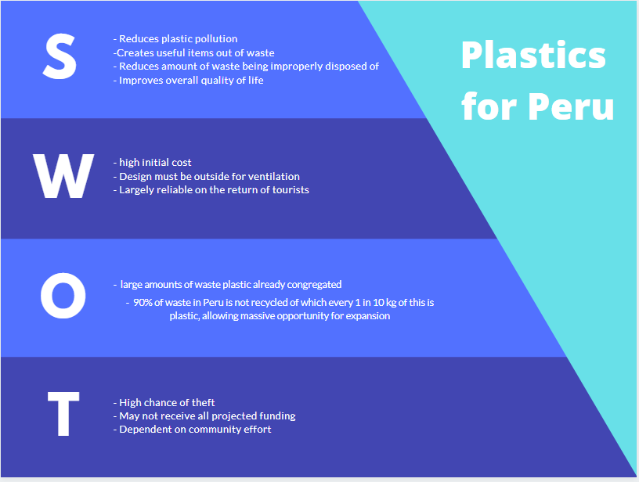

## PESTEL analysis

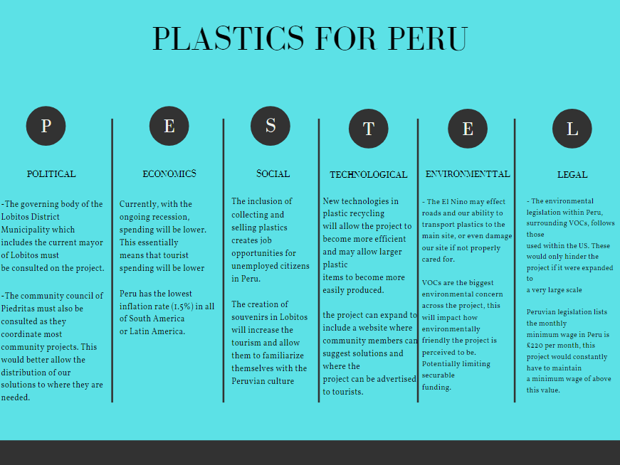

# Solutions

## Table of Solutions

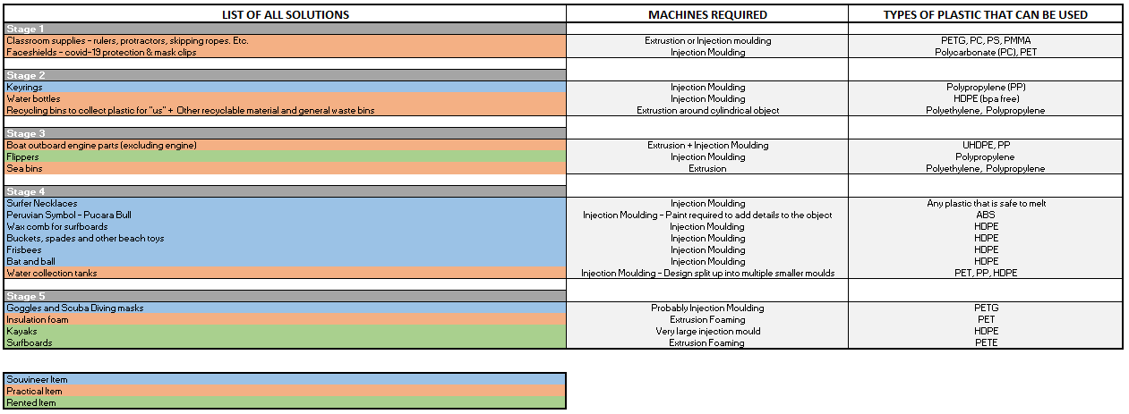

*Figure 5.1.1 – Solutions*

## How solutions will tackle problem areas

The solutions are designed with consideration to the needs of the local people. Both regions don’t have consistent access to safe, clean water and while some people can afford rain collection tanks or ways of storing water when there is available, the poorest cannot so the plan is to build rain collection tanks to give to these people. These tanks, shown in figure 5.2.1, will be of a modular design, allowing for easier production and a more flexible placement that can tailor to a variety of situations. The project will be increasing the ease of which the community can recycle to ensure this doesn’t become a reason why people stop recycling, the plan is to do this by building recycling bins and also general waste bins. Schools in the region need more classroom supplies, many of which can be made using plastic, this will make it easier for the youth of the community to become more educated, allowing more of them to escape poverty. It will also hopefully make them aware of the benefits of recycling from a young age, which will be essential to the longevity of the project. In order to tackle the COVID-19 pandemic, face masks will also be produced. It is the hope that as the project progresses, there will be less need for these products and as such, they can be phased out.

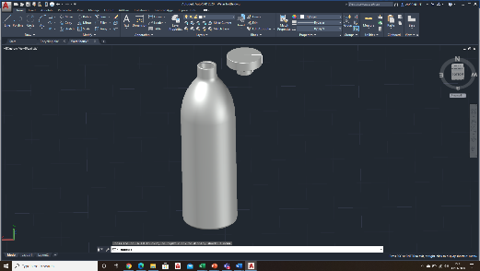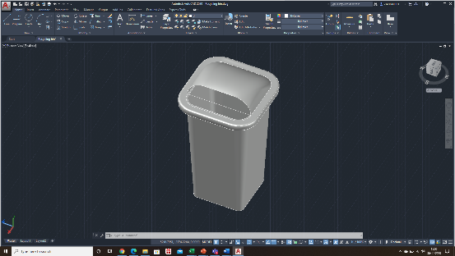

*Figure 5.2.1: From left to right: rainwater collection tanks, water bottles, surfboard keyring, & recycling bin.*

# Risks and Safety

## Health and safety issues

Although to help Lobitos and Piedritas to be a better environment for the residents to live a better life is top priority, health and safety issues was also considered in the process. When products are manufactured, processes such as the preparation of plastics and the manufacturing process involves high power machines which could cause hazards. A list of machines with its risk assessment and prevention will be described in detail.

The workshop will be located outside, increasing ventilation and reducing the toxic fumes the employees are exposed to. With the workshop situated outside, some new safety concerns arise. Largely electrical concerns. These are to be dealt with providing a high-quality canopy that is ensured to waterproof the entire facility. Days of operation are numbered to this when weather conditions are adequate.

Personal protective equipment (PPE) should be worn at all times when in the workshop, these will be presented on figure 6.1.1:

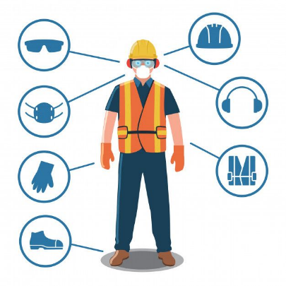

*Figure 6.1.1 – PPE diagram*

Workshop clothes

Ear defender headband

Safety helmet

Steel cap boots

Heat resistance gloves

Face shield

Safety goggles

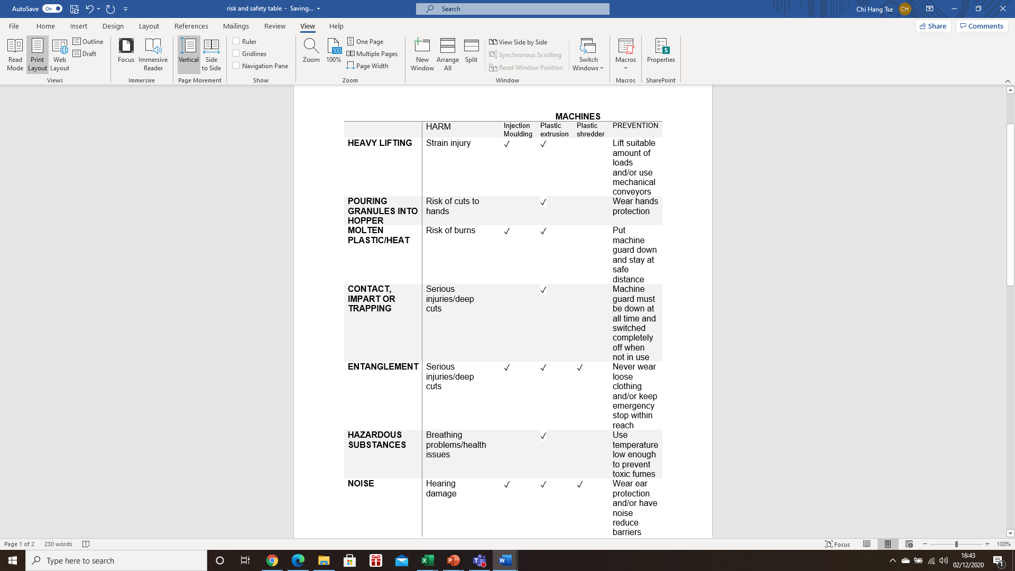

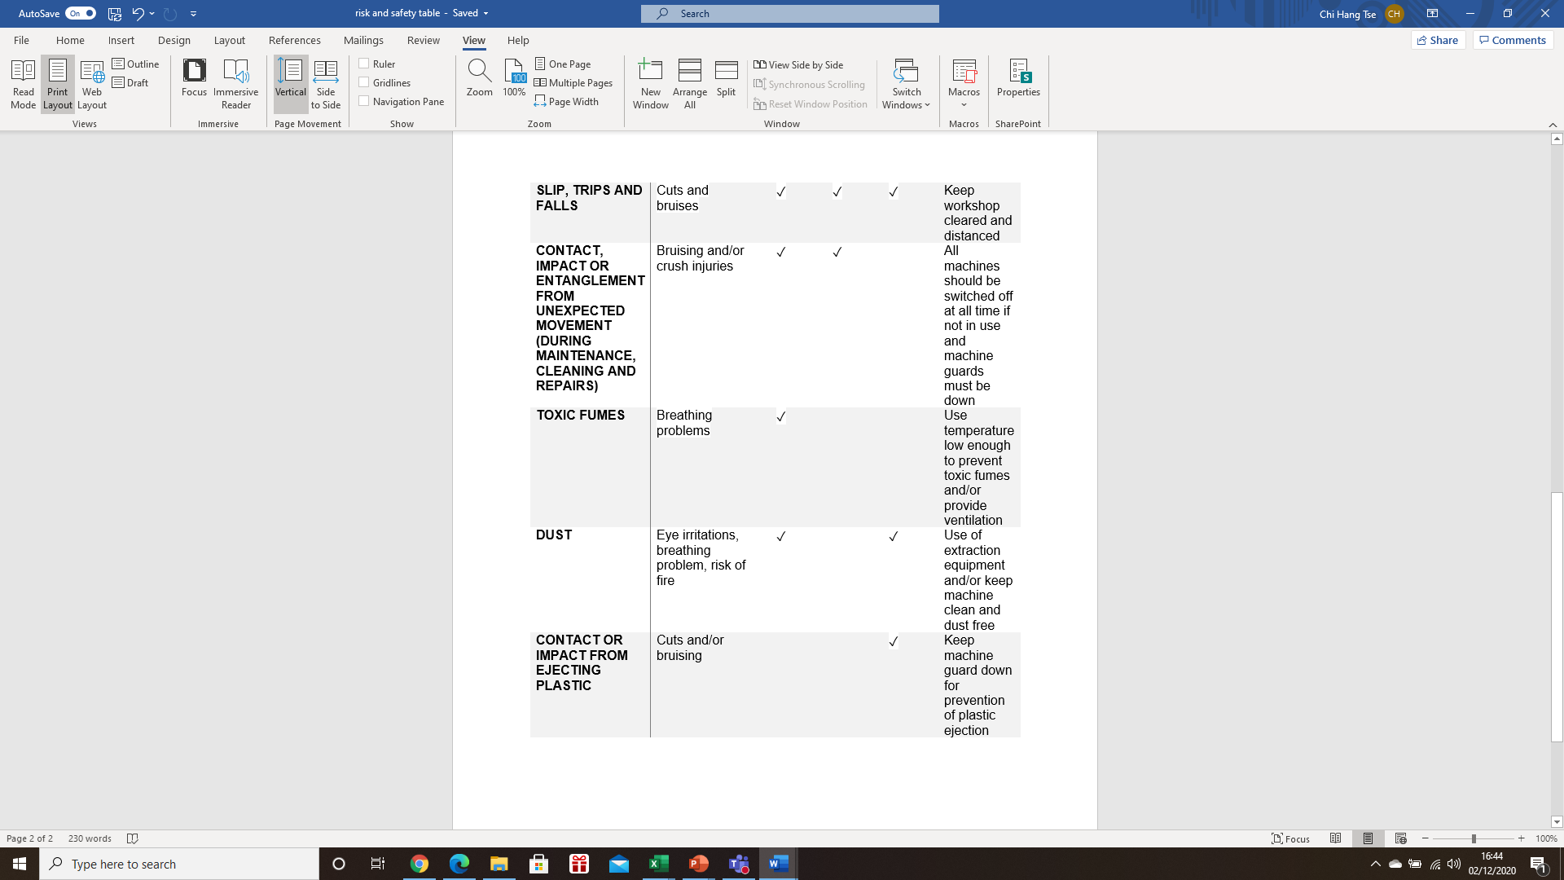

*Figure 6.1.2 – Health and Safety Table*

# Sustainability and Ethics

Plastics for Peru will follow the environmental and sustainability policy set by Gov.uk [37] to ensure we are sustainable and ethical in our business approach.

## Environmental

Plastics for Peru does not focus on how little negative impact we have on the environment but rather what we can do to ensure the environment strives. As the last generation able to put a halt to climate change, drastic steps need to be taken, which is why the entire design process and final solutions have been carefully crafted to fight the biggest waste problem the world has ever seen. This is achieved by using renewable energy sources, where possible, and cleaning waste plastics from areas where wildlife and ecosystems are being destroyed because of plastics intrusion and converting this back into useful items for the local community, putting a stop to the burning and throwing away of plastic in the area.

## Economic

As a charity the main source of income for the project will be from donations, however, revenue will also be raised through selling items to tourists. The design involves the use of solar panels which although have a high initial cost, result in being economically sustainable in the long run. Most of the waste in Peru is not recycled therefore there is a massive way for Peru as a country to improve in waste management and gives Plastics for Peru great opportunity for expansion.

## Social

Plastics for Peru will aim to employ local residents. This will provide much needed jobs in Lobitos and Piedritas which have poverty levels of 30% and 70-80% respectively [33]. The facility will be located in an area far from tourist hotspots as it can be an eyesore and may negatively impact tourism.

## Ethics

# Long-Term Plan

## Future Management

Future management should be completely in the hands of the community. Plastics for Peru will provide training and supervise the installation and implementation of the design to ensure the employees can operate the machine to a high standard. Once this stage has been completed, responsibilities should then be passed solely to the community.

## Expanding the Project Reach

The design allows for a solution to not only the issues in Lobitos and Piedritas but Peru as a whole. It is the initial plan to implement the design into communities like Lobitos or Piedritas and then expand into larger cities to create large infrastructure such as buildings, just like the community centre Justo Blas and Teófilo Erazo are seeking [Appendix 11.2], made of plastic ‘Lego’ style blocks. The project will also continue to manufacture items from earlier stages, and create a variety of new, additional items. It is the hope of the team that the people of Peru will be the ones to solely run these franchises to help better their own community.

## Machine Improvements

As the project progresses, the machines can be upgraded and improved by using the Precious Plastics Website [36]. The community has an open-source system, and so any improvements anyone makes to their machine is uploaded to their system for everyone to use. They are generally easy to construct, with upgrades easy to install. Plastics for Peru would continue to monitor the community in the long term and gradually improve machines over time.

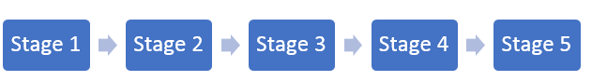

# Improvements

This initiative has the goal to improve the standard of life within both Lobitos and Piedritas. Although the net success of the project can be seen as positive, improvements can still be put in place.

## Cost Efficiency Surrounding the Production of Bigger Items

As previously mentioned in the economics section, section 3, the effectiveness of an item must outweigh the cost of a mould.

An improvement that would allow the project to expand into production of larger and more costly items, would be to increase the demand for these items. Aligning with the principle that if more are produced the ‘return on investment’ (in terms of the money saved for a community), would be drastically improved.

This can only arise if the project is expanded into more of a national scheme, one where items are supplied to struggling locations all over Peru, away from just Lobitos and Piedritas.

## Outreach for a More Reliable Plastic Supply

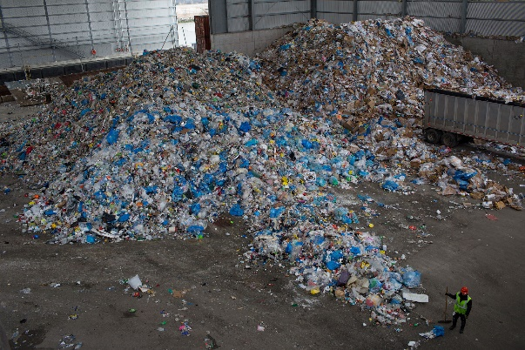In January of 2018 China, the largest consumer of waste plastic, closed its borders to the plastic waste imports of other countries. This left lots of countries, the UK included, with plastic waste and not very much to do with it (Katz, 2019). Often resorting to landfill, burning, or shipping it away to smaller countries in southeast Asia as an alternative (Wang et al., 2019).

Workers collect recycled trash in Brooklyn, New York

 Photographer: Andrew Lichtenstein/Corbis via Getty Images

As this project is expanded, a prediction that can be made is that the plastic required to maintain production, especially if the project is taken nationally in Peru, will not stack up to the intake from local communities. With the chance of a plastic deficit within the project, and a plastic waste overflow within countries around the world, the overlap is clear. If there were a possibility where funding could be obtained through the act of using this overflowing plastic, the project would take a huge step towards self-sufficiency.

## Reducing Emissions

The limitations often placed on a project of this type lie with the emissions produced, with melting plastic being a well-known producer of volatile organic compounds, VOCs. Though VOCs are produced, this method of dealing with plastic waste is still more environmentally friendly than burning the plastic, and better for land and seascape in terms of both wildlife and the lack of decomposition of plastics.

With that being said, emissions are still present, any measures to reduce these would be greatly welcomed. A Japanese study found that the VOC emissions from melting plastics were reduced when the temperature the plastics are melted at was kept towards the lower end of its ‘melt temperature range’, even fewer VOCs emitted when the melting took place closer to anaerobic conditions too (Yamashita, Kumagai, Noguchi and Yamamoto, 2007).

In improving the environmental friendliness of the machines, steps could be taken in order to both reduce the temperature of melting and amount of O2 present.

# Reflective Summary

The EWB challenge was a fantastic opportunity to apply theories and ideas from the Business Awareness, Safety and Sustainability course. Applying the knowledge learned into a real-life scenario allowed us to have a deeper understanding of the content and the vital role it plays in major engineering projects all over the world. As a team, we would keep it as a non-toxic environment to ensure everyone in the group feels comfortable when speaking out their point. With different engineers gathered in one group, it has given us a more in depth and different thinking style when tackling a task. This experience has allowed us to develop our teamwork skills further, in a way different to any other we have experienced at university so far. Working with a range of engineers from different disciplines allowed us to understand what each discipline can bring to a project.

In getting the project done on time, the utilisation of both minutes and agendas was crucial. Having been responsible for the meeting agendas, we found that the content of these helped us keep on track with what was happening and allowed for a general idea of how far through the project we were. The team came across several challenges during the processing stage of the idea. Challenges such as, how the idea would work, how it satisfies the specification, and other considerations such as short to long term plans, economic analysis and health and safety. To overcome these challenges, as a team we would consider this as a ‘real-life’ event where we would consider how a company or even a non-profit association would attack these situations. The frequency of meetings ensured that in any cases where there was confusion or other issues they could be addressed fairly quickly while still allowing people to fit the work around their own schedule.

The project could not be completed as well without a team leader, as a group we have decided to assign Cameron as our team leader to organise meetings throughout the week and assign tasks to each one of us. This allows us to plan ahead before the next meeting starts. Despite having a team leader, all major decisions, including ones on the direction of the project, were decided as a team with an equal voice for all members. More minor or specific decisions within tasks were trusted to the group member or members undertaking said task as often they would have more knowledge in this area. The team itself were dedicated to the task from the outset and we quickly set up the initial tasks of coming up with team roles.

# References & Bibliography

1. Preciousplastic.com. 2020. *Precious Plastics Information*. [online] Available at: <https://preciousplastic.com/> [Accessed 1 December 2020].
2. 2020. [online] Available at:

<https://www.wwf.org.pe/en/?uNewsID=328834> [Accessed 30 November 2020].

1. Greenmatch.co.uk. 2020. What Is The Return On Solar Panel Use In The UK? | Greenmatch. [online] Available at:

<https://www.greenmatch.co.uk/blog/2014/07/how-long-will-a-solar-panel-take-to-pay-for-itself-in-the-north-of-uk> [Accessed 30 November 2020].

1. Salfordvanhire.com. 2020. Hire A 17/18 Tonne GVW Box Van With Tail Lift HGV / LGV - Salford Van Hire, Manchester & Leeds. [online] Available at: <http://www.salfordvanhire.com/Ref_445.html> [Accessed 30 November 2020].
2. Local.armacell.com. 2020. [online] Available at: <https://local.armacell.com/fileadmin/cms/pet-foams/Brochure/brochure_from_bottle_to_foam_WEB.pdf> [Accessed 30 November 2020].

Omni processor information:

1. Onabanjo, T., Kolios, A., Patchigolla, K., Wagland, S., Fidalgo, B., Jurado, N., Hanak, D., Manovic, V., Parker, A., McAdam, E., Williams, L., Tyrrel, S. and Cartmell, E., 2016. An experimental investigation of the combustion performance of human faeces. *Fuel*, 184, pp.780-791.
2. 020. [online] Available at:

<https://www.youtube.com/watch?v=msItOYF5BcA> [Accessed 30 November 2020].

Methods of Recycling:

1. Shini USA. 2020. What Are Resin Pellets And How Are They Utilized In Manufacturing? | Shini USA. [online] Available at: <https://www.shiniusa.com/2019/03/22/resin-pellets/> [Accessed 30 November 2020].
2. Bpf.co.uk. 2020. *Plastic Recycling*. [online] Available at: <https://www.bpf.co.uk/sustainability/plastics_recycling.aspx> [Accessed 30 November 2020].
3. Grigore, M., 2017. Methods of Recycling, Properties and Applications of Recycled Thermoplastic Polymers. *Recycling*, 2(4), p.24.

Typing of Plastics:

1. Turku, I., Kärki, T., Rinne, K. and Puurtinen, A., 2016. Characterization of plastic blends made from mixed plastics waste of different sources. *Waste Management & Research*, 35(2), pp.200-206.
2. Irjet.net. 2020. [online] Available at:

<https://www.irjet.net/archives/V6/i4/IRJET-V6I4238.pdf> [Accessed 30 November 2020].

1. Vinylplus.eu. 2020. [online] Available at: <https://vinylplus.eu/uploads/downloads/VinylPlus_Recycling_Technologies_30012017.pdf> [Accessed 30 November 2020].
2. Our World in Data. 2020. *Faqs On Plastics*. [online] Available at: <https://ourworldindata.org/faq-on-plastics#recycling-landfill-or-incineration-which-should-we-choose> [Accessed 30 November 2020].
3. EcoMENA. 2020. *Recycling Of PVC - Prospects And Challenges | Ecomena*. [online] Available at: <https://www.ecomena.org/recycling-pvc/> [Accessed 30 November 2020].

Items to produce:

1. 2020. [online] Available at:

<https://www.wwf.mg/?uNewsID=357542> [Accessed 30 November 2020].

Moulding plastic:

1. Ptonline.com. 2020. *The Importance Of Melt &Amp; Mold Temperature*. [online] Available at: <https://www.ptonline.com/articles/the-importance-of-melt-mold-temperature> [Accessed 30 November 2020].
2. 3D Systems. 2020. *Basics Of Injection Molding Design | 3D Systems*. [online] Available at: <https://uk.3dsystems.com/quickparts/learning-center/injection-molding-basics> [Accessed 30 November 2020].
3. Santin, D., 2020. 11 Questions To Ask Before Picking A Plastic Mold Manufacturing Partner. [online] Micronsolutions.com. Available at: <https://www.micronsolutions.com/blog/plastic-mold-manufacturing-partner> [Accessed 30 November 2020].
4. Www-sciencedirect-com.ezproxy1.hw.ac.uk. 2020. [online] Available at: <https://www-sciencedirect-com.ezproxy1.hw.ac.uk/book/9781569906897/plastics-injection-molding> [Accessed 30 November 2020].

Funding the project:

1. Global Environment Facility. 2020. *Projects*. [online] Available at: <https://www.thegef.org/projects-faceted?f%5B0%5D=field_country%3A128&page=5> [Accessed 30 November 2020].
2. GOV.UK. 2020. *Small Charities Challenge Fund (SCCF)*. [online] Available at: <https://www.gov.uk/international-development-funding/dfid-funded-small-charities-challenge-fund-sccf> [Accessed 30 November 2020].
3. GOV.UK. 2020. *UK Aid Direct*. [online] Available at: <https://www.gov.uk/international-development-funding/uk-aid-direct> [Accessed 30 November 2020].
4. Coca-colacompany.com. 2020. What Type Of Grants Or Requests Does Coca-Cola Provide? | The Coca-Cola Company. [online] Available at: <https://www.coca-colacompany.com/faqs/what-type-of-grants-or-requests-does-coca-cola-provide> [Accessed 30 November 2020].

Shipping:

1. MoveHub. 2020. *Movehub UK | Compare Quotes For International Shipping*. [online] Available at: <https://www.movehub.com/uk/international-shipping/peru/> [Accessed 30 November 2020].

Salaries

1. Salaryexplorer.com. 2020. *Average Salary In Peru 2020 - The Complete Guide*. [online] Available at: <http://www.salaryexplorer.com/salary-survey.php?loc=170&loctype=1> [Accessed 30 November 2020].

Fences:

1. Prestonfencing.com. 2020. Fencing Prices | Fence Costs| Industrial Fencing | Commercial Fencing | Security Fencing| Agricultural Fencing | Steel Palisade Fencing | Paladin Fencing | Chain Link Fencing | Fence Concrete Posts. [online] Available at: <http://www.prestonfencing.com/prestonfencingPricing.html> [Accessed 30 November 2020].

Bins:

1. Recycling, W., Bins, L., Bins, P., Litre, E. and Litre, E., 2020. *Eco Recycled Hooded Top Litter Bin - 90 Litre - Kingfisher Direct Ltd*. [online] Kingfisher Direct Ltd. Available at: <https://www.kingfisherdirect.co.uk/eco-recycled-hooded-top-litter-bin-90-litre?language=en&currency=GBP> [Accessed 30 November 2020].
2. Recycling, W., Bins, L., Bins, T., Capacity, T. and Capacity, T., 2020. *Taylor Continental Wheeled Bin - 1280 Litre Capacity - Kingfisher Direct Ltd*. [online] Kingfisher Direct Ltd. Available at: <https://www.kingfisherdirect.co.uk/taylor-continental-wheeled-bin-1280-litre-capacity> [Accessed 30 November 2020].

Risk and Safety:

1. Zealand, W., 2020. *Injection And Blow Moulding*. [online] WorkSafe. Available at: <https://worksafe.govt.nz/topic-and-industry/machinery/working-safely-with-plastic-production-machinery/injection-blow-moulding/> [Accessed 30 November 2020].
2. Zealand, W., 2020. *Plastics Extrusion Presses*. [online] WorkSafe. Available at: <https://worksafe.govt.nz/topic-and-industry/machinery/working-safely-with-plastic-production-machinery/plastics-extrusion-presses/> [Accessed 30 November 2020].
3. Zealand, W., 2020. *Plastics Granulator*. [online] WorkSafe. Available at: <https://worksafe.govt.nz/topic-and-industry/machinery/working-safely-with-plastic-production-machinery/plastics-granulator/> [Accessed 30 November 2020].
4. EWB design brief
5. Our World in Data. 2020. *FAQs On Plastics*. [online] Available at: <https://ourworldindata.org/faq-on-plastics#recycling-landfill-or-incineration-which-should-we-choose> [Accessed 1 December 2020].

Case Studies:

1. Engineers Without Borders UK. 2020. *Case Study Overview - Engineers Without Borders UK*. [online] Available at:

<https://www.ewb-uk.org/group/case-studies-overview/> [Accessed 2 December 2020].

Precious Plastics:

1. Preciousplastic.com. 2020. *Say Hi To The Precious Plastic Universe*. [online] Available at:

<https://preciousplastic.com/> [Accessed 2 December 2020].

1. GOV.UK. 2020. *Environmental And Sustainability Policy*. [online] Available at: <https://www.gov.uk/government/publications/environmental-and-sustainability-policy> [Accessed 2 December 2020]

# Appendicies

## Typing of Plastics & if they are recyclable

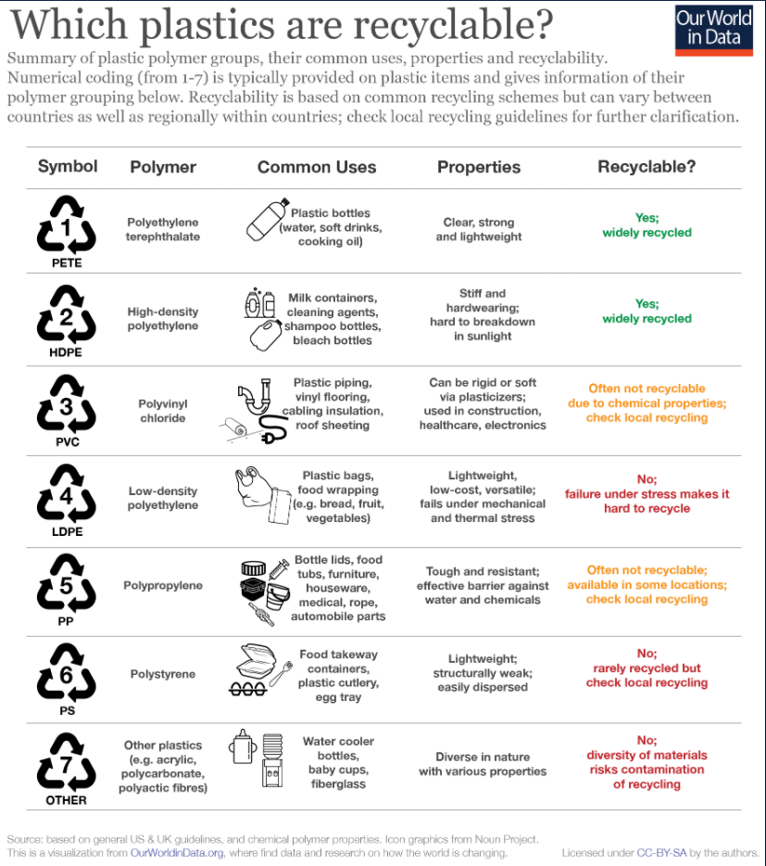

|  |  |
| --- | --- |
| **Who are we helping?** | **How are we helping?** |
| Teófilo Erazo  (Electrification, Infostructure and construction) | Helping to electrify both towns as he has already electrified 80% of Piedritas. He also wants to construct a town hall made from an alternative material to contract and cement. In stage 5, alongside Justo, Plastics for Peru can provide plastic bricks which easily click into place and a community centre can be constructed. |
| Justo Blas  (Construction) | At stage 4 or 5, can start to produce plastic bricks so we can then build buildings. This means that he can collaborate with Plastics for Peru and aid in constructing the local community centre. |
| Augusto Correa  (Recycling) | Promote the idea of a renewable business by working alongside Augusto Correa as he already has an established business that is environmentally conscious. |
| Quenni Carreno  (Tourism (Souvenirs)) | She has a great insight into the soigneurs business and can be a great product consultant by helping design products from stage 3 onwards |
| Nicolás Landa  (Tourism and School) | With his knowledge and history of the local area, he can aid the project by collaborating with Plastics for Peru to help create unique products to sell to tourists. He can also advise the project as how to set up a collaboration with the school to help organise litter picking classes and classes on recycling, for example. |
| Marlyne Guerrero  (Tourism) | As a prominent member of the tourism community, she can help he project by organising community meetings to promote the project and to raise awareness. |
| Manuel Vásquez  (Schools) | Plastics for Peru can work closely alongside Manuel Vásquez to help to supply the school with items such as rulers and protractors. As the project progresses to stage 4 and 5, an outdoor area could be constructed from the bricks and a roof could be created using plastic beams. |
| Tullio Chapilliquén  (Fishing) | Tullio Chapilliquén can work in collaboration with Plastics for Peru during stage 3, where he can give advice on boat parts that can be constructed to aid the local fishermen. |
| EcoSwell | EcoSwell are trying to increase ecotourism in the area. This project would substantially increase ecotourism as they will want to come and see the factory and learn about the project at the same time. |

## Case Studies

## Fault report checklist

**Date inspected:** ……… **Employee Name:** …………… **Witness:** ……………….

|  |  |  |  |
| --- | --- | --- | --- |
| Area | Pass | Fail | Comments |
| Battery |  |  |  |
| Injection moulder |  |  |  |
| Moulds |  |  |  |
| Surrounding landscape |  |  |  |
| Pollution control |  |  |  |
| ventilation |  |  |  |
| fencing |  |  |  |
| Heating element |  |  |  |
| Temperature control |  |  |  |
| Safety equipment |  |  |  |
| Truck health |  |  |  |
| Collection bins |  |  |  |
| Blade sharpness |  |  |  |
| Blade structure |  |  |  |
| Chain |  |  |  |
| Bike |  |  |  |
| Solar panels |  |  |  |
| Wiring |  |  |  |

## Gannt Charts

### Team Gantt Chart

### Long Term Gantt Chart

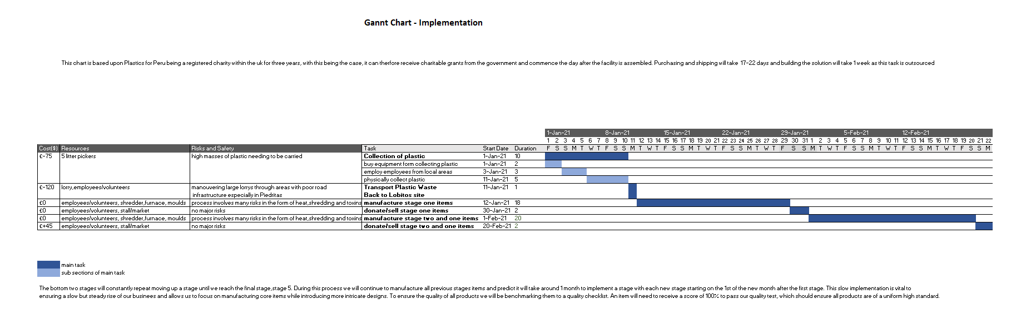

## Economics

### Cash Flow Statement and IRR

### 



### NPV



### Closing Monthly Balance

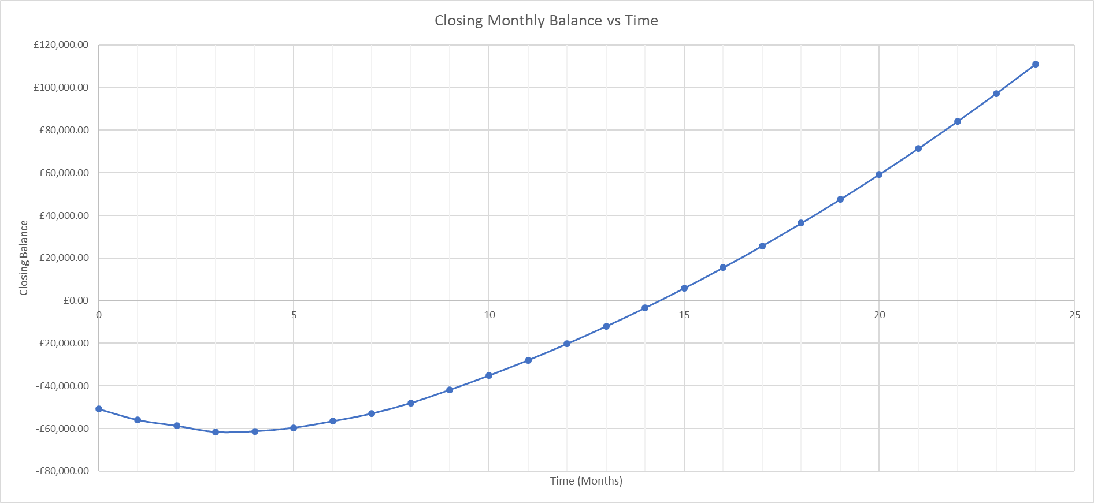

### Feasibility Table



## The Team

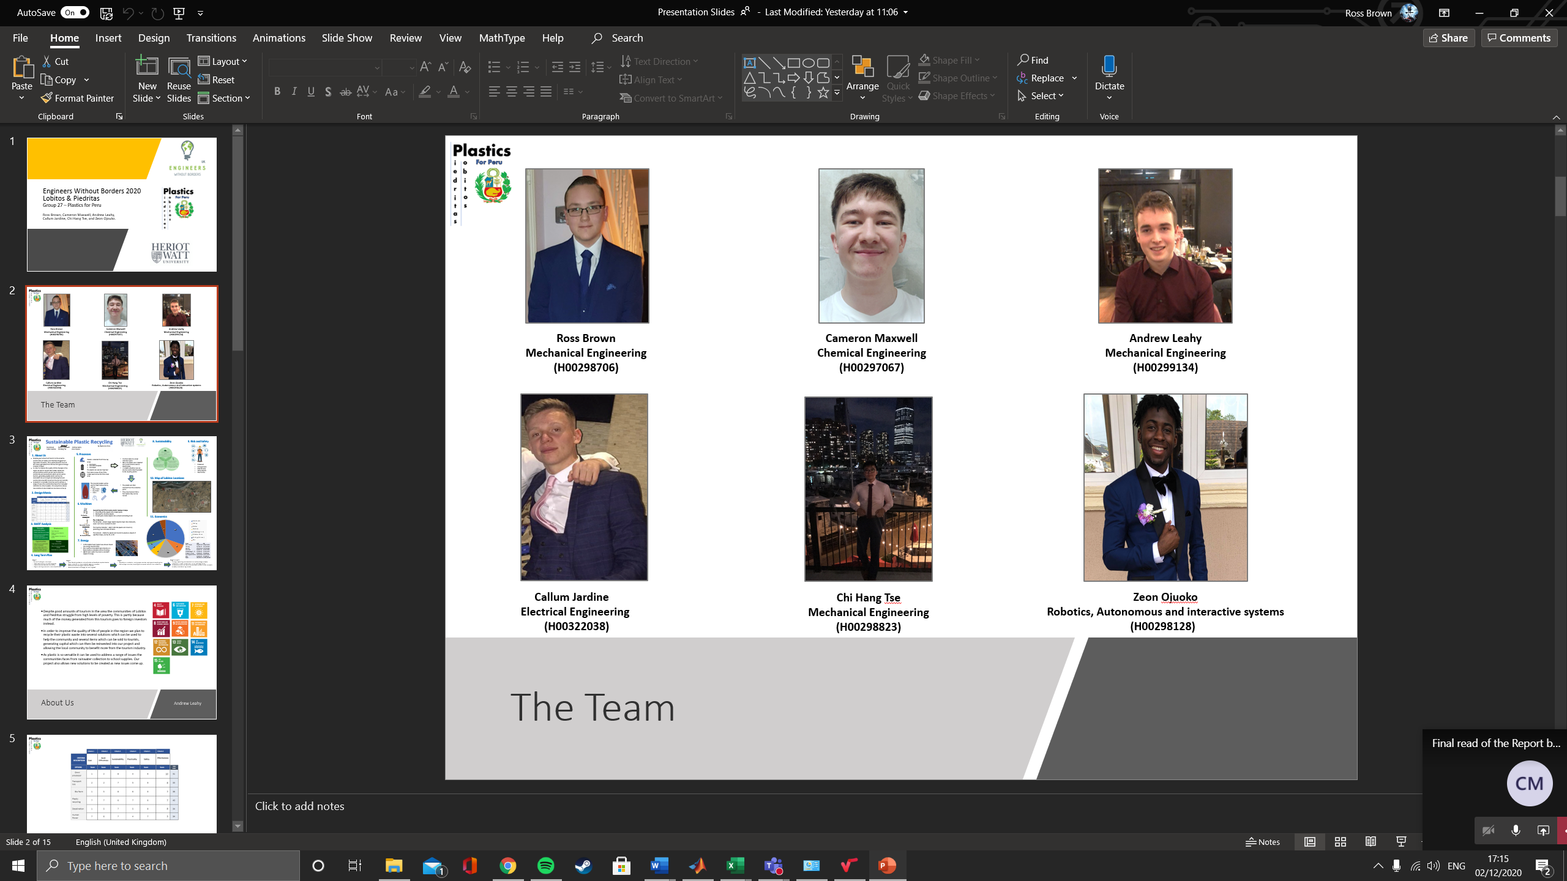

**Course director:** Reza Mohammadi

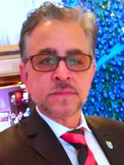

## Personal Statements

**Callum Jardine**

The EWB challenge was a fantastic opportunity to apply theories and ideas from the Business Awareness, Safety and Sustainability course. Applying the knowledge learned into a real-life scenario allowed me to have a deeper understanding of the content and the vital role it plays in major engineering projects all over the world. Furthermore, the EWB project was a great way of experiencing a real-life scenario where engineers from all disciplines come together to create a solution to a problem. I found myself learning a great amount from my peers, lectures, and own research throughout the project in relation to common engineering practices, economics, ethics, marketing, sustainability and health and safety.

The group was quick and efficient from the start with a welcoming approach from all members making communicating initial ideas and thoughts easy and productive. The team showed excellent time management from the start as we were able to organise 2 meetings a week even with everyone having different timetables and commitments. The use of two meetings a week proved pivotal to our solution as it allowed us to discuss questions and ideas which were arriving quickly and each more in detail throughout the entire project.

Meetings would generally involve all members however it was not uncommon for members to meet individually in their subgroups for larger tasks that had been delegated to a team rather than an individual. In our meetings we would each individually present our research or work to the team in which they would then offer their opinions and further ideas on. Generally, we would delegate two tasks each week per member, one being a smaller task to complete over the weekend and the other a more research-intensive task in which we would pitch back to the team in the next meeting. The even splitting of tasks highlighted our teamwork as all members were happy to complete the tasks given and help was always available to anyone struggling via our group chat. The result of this was extremely efficient meetings and allowed us to complete the project in good time before the deadline.

The lectures were extremely relevant to the content of the project however a more detailed explanation of the design brief would of allowed for a quicker start, initially as a group we were confused to the extent and boundaries of the project such as finances and the detail needed of the machine design.

Cameron took the leadership role, as a team we believed it was important to not have a boss but rather a leader in whom would lead meetings and delegate tasks to ensure we were being as efficient as possible and carrying out the work to the highest standard, Cameron carried out this role incredibly well and was always prepared and fair in every meeting.

The team throughout the project worked extremely well together resulting in a well-made report and poster in which we are all extremely happy with.

**Andrew Leahy**

This experience has allowed me to develop my teamwork skills further, in a way different to any other I have experienced at university so far. Working with a range of engineers from different disciplines allowed me to understand what each discipline can bring to a project as well as what best I can bring to a project. This range of understandings and knowledge challenged me to develop my communication skills and my ability to explain technical aspects without having to go into all the specific details. The base of this task partly in business as well as engineering allowed me to accept tasks outside my comfort zone and grow my skillset.

We held meetings bi-weekly, one on a Monday and one on a Friday, this allowed us to assign smaller tasks to each member. After completing the separate tasks, we then came together as a team to make big decisions, evaluate smaller decisions, and identify challenges. The smaller tasks completed by each member between meetings could be collated into the bigger goals we aimed to achieve week by week, allowing us to ascertain the progress of the project regularly. The frequency of meetings ensured that in any cases where there was confusion or other issues they could be addressed fairly quickly while still allowing people to fit the work around their own schedule. As the project progressed, we were able to discover who was best at what type of work and assign tasks better in the future to match everyone’s strengths.

This project allowed me to experience problem solving scenarios based on engineering design in real applications. It also allowed me to apply the business techniques and knowledge I learnt on this course to our design. The combination of the two allowed me to further understand the way in which they are required to work in tandem in industry and real-life applications.

Our team’s leadership structure had a single team leader who had the main purpose of focusing the team on the required tasks and timeline for these tasks. He was required to take responsibility for ensuring each team member was assigned a task each week. This process was generally achieved on a voluntary basis but in scenarios where additional tasks were required to meet our timeline or where a group member did not have a task, Cameron ensured this was done. Despite having a team leader, all major decisions, including ones on the direction of the project, were decided as a team with an equal voice for all members. More minor or specific decisions within tasks were trusted to the group member or members undertaking said task as often they would have more knowledge in this area.

I thoroughly enjoyed working with this team, I found it to be very cohesive and feel we achieved our goals with good time management and to a high standard. Each member contributed equally, and I learnt a lot from the experience, both in terms of hard and soft skills.

**Cameron Maxwell**

In participating in the EWB challenge 2020, as a part of the B49CB course, I have gained a plethora of new skills, all essential for my progression into the working world. From day zero, integrating myself within the team was essential, judging the different personality types and how they would respond to certain roles/tasks. The ability to take criticism on ideas was also good to learn, knowing that everyone simply wants the best for the project and if you ask for feedback on an idea then you will get an honest response.

In getting the project done on time, the utilisation of both minutes and agendas was crucial. Having been responsible for the meeting agendas, I found that the content of these helped me keep on track with what was happening and allowed for a general idea of how far through the project we were. Running into problems was also a learning point. Having the maturity to respond with a calm and sensible demeanour allowed solutions to be found in little time, putting the project into a real perspective also helped in this. Putting ourselves into the mind of a member of the Lobitos or Piedritas community, from my perspective, was the best way to do this.

I decided to take on a leadership role at the beginning of the project. I tend to enjoy the challenge of steering the direction of a project. I feel that it is always best to take a light leadership role, allow a democracy so that ideas are that of the team rather than an individual, diversifying the scope of the project. Through taking the lead, I learned how to properly assign tasks and correctly chase people up on deadlines, all without being intrusive, or disrespectful to their other University work. I would never have been able to be as successful within this role without a supportive team, helping me when I struggled to assign tasks or find a direction for the weekly meeting. All members were really enjoyable to work with.

From the course I have learned more teamwork and leadership skills than anything else, even business. Though I found the lectures relatively uninformative, the application of the proposed skills through the EWB project helped me gain more of a business perspective than ever. It also taught me the ability to actually rely on my teammates to do good work, rather than wanting to change ever small detail. The course even pushed me to apply and eventually take on a role as the Chair of the student parliament at Heriot-Watt, all because I enjoyed the group leadership position so much.

My only suggestion to improve the course is to make more use of the lecture time, this could be achieved by teaching more practical content. I, personally, found the lecture material was either common sense or information that I would never have any use for.

**Ross Brown**

When first starting this project, I admit I did fail to see its relevance to my own degree. But then I thought, creating a product or service for a community or person that needs help resolving an issue is exactly what I would be doing as an engineer, as well as working with other types of engineers to create a system or product to better advance a community and aid them.

When we first met, we clicked extremely well as a group and the leadership structure fell into place quickly and was satisfactory for all team members. We decided that it would be best to have a leader that would, instead of giving orders, acted more as a guide to us. Cameron would ensure we met deadlines and that tasks were fairly distributed amongst all members and collectively, we would agree on decisions as opposed to one person controlling the task. The team itself were dedicated to the task from the outset and we quickly set up the initial tasks of coming up with team roles, such as myself and Callum alternating taking meeting notes. We also decided to each come up with an idea and pitch to our other teammates.

The ideas generated were creative, well-constructed and would make a lasting impact on the community regardless of the project we ended up pursuing. We eventually narrowed it down to two projects, my own project of a renewable, self-sustaining farm and Cameron’s project. After extensive research and great debate, we concluded that we would go with Cameron’s idea as the costs were substantially lower compared to my own project idea.

Initially, it was decided that we would meet at set times, but as the project progressed, it became apparent that we needed to meet as often as three or four times a week as we had a lot to discuss and we could only say so much over social media.

The guidance offered by the EWB lectures and the staff, especially Reza, heavily influenced this project and helped to structure it in an efficient and professional manner. If some team members could not make it to the classes, then those who did attend were able to fill in and guide the other members so that no one missed out on the crucial information that was being taught.

A lot of trust was needed in order to successfully complete this task. We needed to trust one and other that we could complete the work designated to us in the specified time frames set by Cameron and the team as a whole. It was also applicable when sharing tasks and information as we relied on the other member to fulfil their part in time so that the other member could proceed with their part. I can say that as a whole, this team has been incredibly reliable and trusting with one and other. I can say for a certainty that we did not perform as a group, but as a team.

**Chi Hang Tse**

The EWB project has helped me to develop/gain a lot of skills such as teamwork, communication, leadership, and problem solving. This has hugely increased my confidence when working as a group. The team organises two meetings per a week where each member in the group would have 5 minutes individual speech without any interruption to present their research. As a team, we would keep it as a non-toxic environment to ensure everyone in the group feels comfortable when speaking out their point. With different engineers gathered in one group, it has given me a more in depth and different thinking style when tackling a task.

The team came across several challenges during the processing stage of the idea. Challenges such as how the idea would work, how it satisfies the specification, and other considerations such as short to long term plan, economic analysis and health and safety. To overcome these challenges, as a team we would consider this as a ‘real-life’ event where we would consider how a company or even a non-profit association would attack these situations. Time management was also a factor that we need to consider since everyone in the group has other deadlines in their course. To manage our time wisely, tasks would be assigned to each member in the group to complete before the next meeting therefore we could complete this project in a non-rushed manner.

The project could not be completed as well without a team leader, as a group we have decided to assign Cameron as our team leader to organise meetings throughout the week and assign tasks to each one of us. This allows us to plan ahead before the next meeting starts. It was safe to say that Cameron had good leadership skills when leading the team and that is something I have learned from him during this project. A mutual trust from everyone was needed to ensure that the assigned task is completed so that it would not delay the group’s deadlines. The team was very supportive throughout the entire time, members in the team would offer to help complete the assigned task if any of us were to struggle. This have showed me that teamwork and communication has a vital role in order to tackle any difficulties.

From the course as a whole, I have gained a lot of creativity and communication skills. With the lectures assisting me with explanation of how a business would work and multiple considerations must be made in order to satisfy the needs of the consumers. Although the lectures got me through some of the stuff, but I do feel like they were not as informative as they should be. My only suggestion to improve this course would be to change some of the lecture slides and making them more informative – with a more in-depth explanation in key areas or calculations so that when it is being looked back at, it will not be as confusing.

**Zeon Ojuoko**

This entire experience EWB project has been an enriching experience because I have learned a wide range of skills that will positively impact my life, while enjoying every moment along the way. Through this journey, I have made a strong connection with five enthusiastic engineers that have the spirit to achieve their goal. The past few weeks working on project to help a third-world country improve economically has driven us closer together and allowed everyone to grow spiritually.

Every Monday and Friday afternoon, we would meet up on teams and speak amongst one another about the task in hand. Every session on team would be in a relaxed environment, while remaining focused on what is needed to be accomplished for that day. The structure of each session was greatly organised because every task was clear and concise. Each member of Group 27 would have their turn to speak and everyone will intently listen to what the person is saying. At the end of every session, everyone would know what their tasks were for the week. This strong communication within the group allow our productivity to flourish and easily complete tasks for the next week.

Whenever a problem came up in the group, everyone would be understanding towards it and always find a way to work around that problem. This was greatly highlighted when I was struggling to determine the correct energy requirements for the project. The instant help I received from the members just showed that we were a loving team that looked out for each other. The appreciation I felt for everyone couldn’t be described at that point knowing that I was to never feel alone during this project.

Personally, the most enhancing part of this experience was performing the presentation. This allowed us to collaborate our work together and show the effort that we have put in and show the examiners how our teamwork has paid off. I especially enjoyed explaining our results and decisions for this project, this process really brought the whole group together as a family.

Overall, I would like to give my team a special thank you because we have progressed our skills every week and have managed to produce an amazing project. Furthermore, a project that cleans plastic to help the environment of Peru, while creating jobs to help their economy. This memorable experience was a blessing to be a part of and to be working with kind-hearted engineers that will go far in the industry and in life.